**SQL QUERY**

**KPI’s**

1. **Total Revenue**

select sum(total_price) as "Total_Revenue"

from pizza_sales

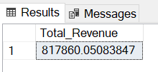

1. **Average Order Value**

select sum(total_price) / count(distinct order_id) as "Avg. Order Value"

from pizza_sales

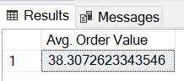

1. **Total Pizza Sold**

select sum(quantity) as "Total Pizza Sold "

from pizza_sales

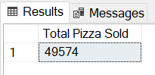

1. Total Orders

select count(distinct order_id) as "total Order"

from pizza_sales

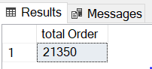

1. Avg. Pizza’s Per Order

select sum(quantity) / count(distinct order_id) as "avg. pizza's per order"

from pizza_sales

**OR**

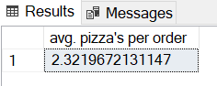 select cast(sum(quantity)as decimal (10,2)) / count(distinct order_id) as "avg. pizza's per order"

from pizza_sales

**Charts**

1. Daily Trend For Orders

select DATENAME(dw,order_date) as "Order_days", count(distinct order_id ) as "Total order"

from pizza_sales

group by DATENAME(dw,order_date)

-- NOTE -: 'DW' stands for "Day of Week". It is used to extract the weekday number (1 to 7) from a DATE value.

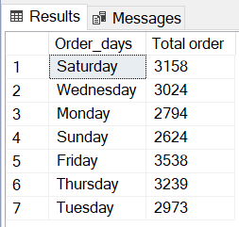

1. Monthly Trend For Orders

select DATENAME(month, order_date) as "month name", count(distinct order_id ) as "Total order"

from pizza_sales

group by DATENAME(month, order_date)

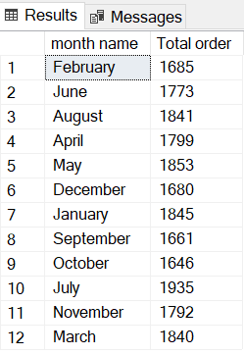

1. Percentage of sales by pizza category

select pizza_category, cast (sum(total_price) * 100 / (select sum(total_price) from pizza_sales) as decimal (10,2)) as PCT

from pizza_sales

group by pizza_category

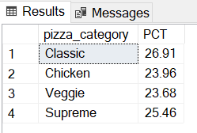

1. Percentage of sales by pizza Size

select pizza_size, cast (sum(total_price) * 100 / (select sum(total_price) from pizza_sales where month(order_date) = 3) as decimal (10,2)) as PCT

from pizza_sales

where month(order_date) = 3

group by pizza_size

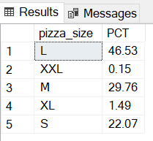

**Note:** month(order_date) = 3 (This indicates the output for the month of March. You can find the output for any other month by entering its corresponding month number.)

1. TOP 5 Pizza by Revenue

select top 5 pizza_Name , sum(Total_price) as "Total Revenue"

from pizza_sales

group by pizza_name

order by [Total Revenue] DESC

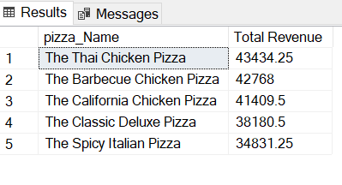

1. Bottom 5 Pizza by Revenue

select top 5 pizza_Name , sum(Total_price) as "Total Revenue"

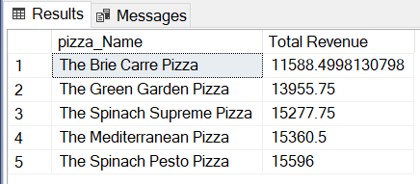 from pizza_sales

group by pizza_name

order by [Total Revenue] ASC

1. TOP 5 Pizza by Quantity

select top 5 pizza_Name , sum(quantity) as "Total Quantity"

from pizza_sales

group by pizza_name

order by [Total Quantity] DESC

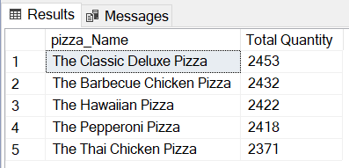

1. Bottom 5 Pizza by Quantity

select top 5 pizza_Name , sum(quantity) as "Total Quantity"

from pizza_sales

group by pizza_name

order by [Total Quantity] ASC

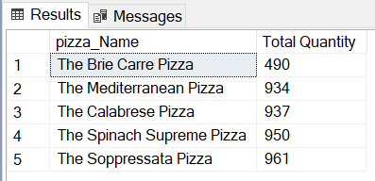

1. TOP 5 Pizza by Orders

select top 5 pizza_Name , Count(distinct order_id) as "Total orders"

from pizza_sales

group by pizza_name

order by [Total orders] DESC

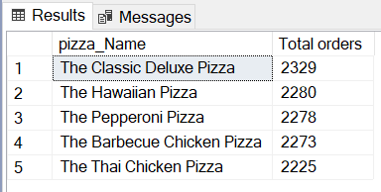

1. Bottom 5 Pizza by Orders

select top 5 pizza_Name , Count(distinct order_id) as "Total orders"

from pizza_sales

group by pizza_name

order by [Total orders] ASC

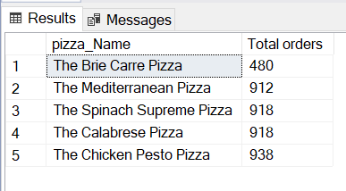

POWER BI Query

**KPI’s**

1.Total Revenue

Total Revenue = sum(pizza_sales[total_price])

2. Total Order

Total order = DISTINCTCOUNT(pizza_sales[order_id])

3. Avg. Order Value

Avg. Order Value = [Total Revenue]/[Total order]

4. Avg. Pizza per Order

Avg. pizza per order = [Total Pizza Sold]/[Total order]

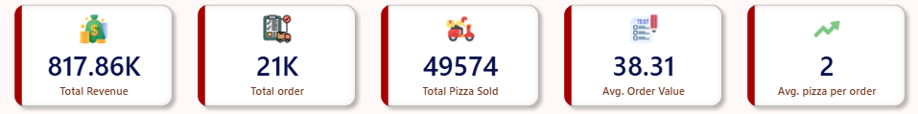

**CHARTS**

5. Daily Trend For Orders

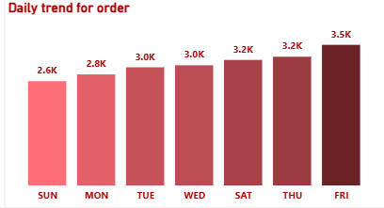

6. Monthly Trend For Total Orders

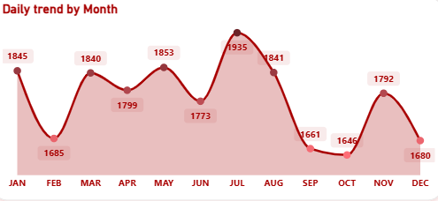

7. % of Sales Pizza By Category

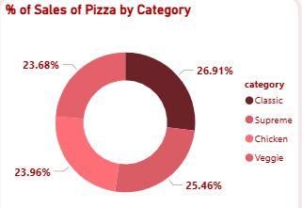

8. % of Sales Pizza By Size

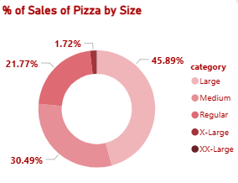

9. Total Pizza Sold By Category

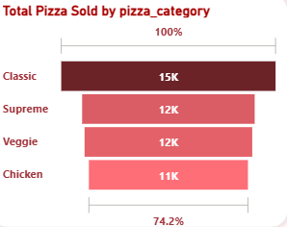

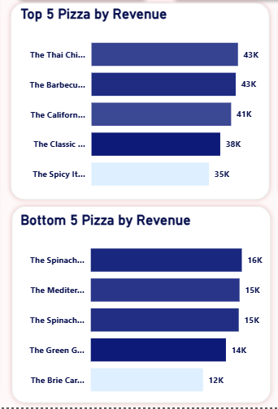TOP and Bottom 5 Sellers by Revenue

**TOP and Bottom 5 Sellers by Quantity**

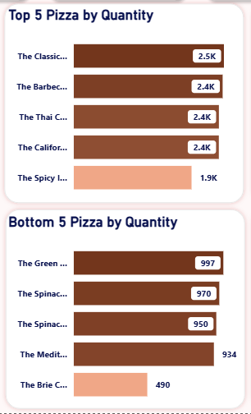

**TOP and Bottom 5 Sellers by Total Orders**

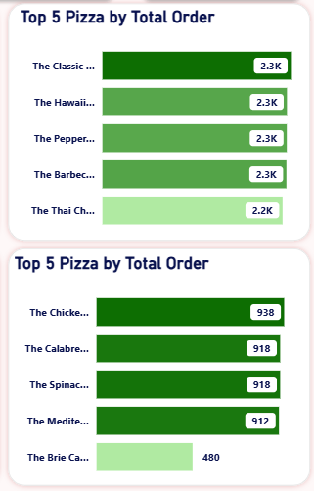

**DASHBOARD**

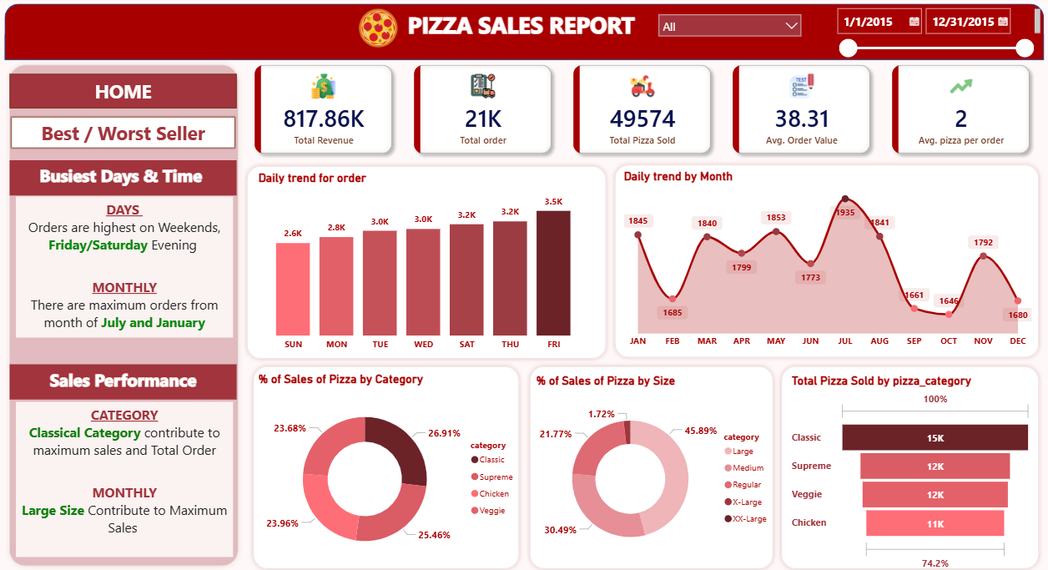HOME PAGE

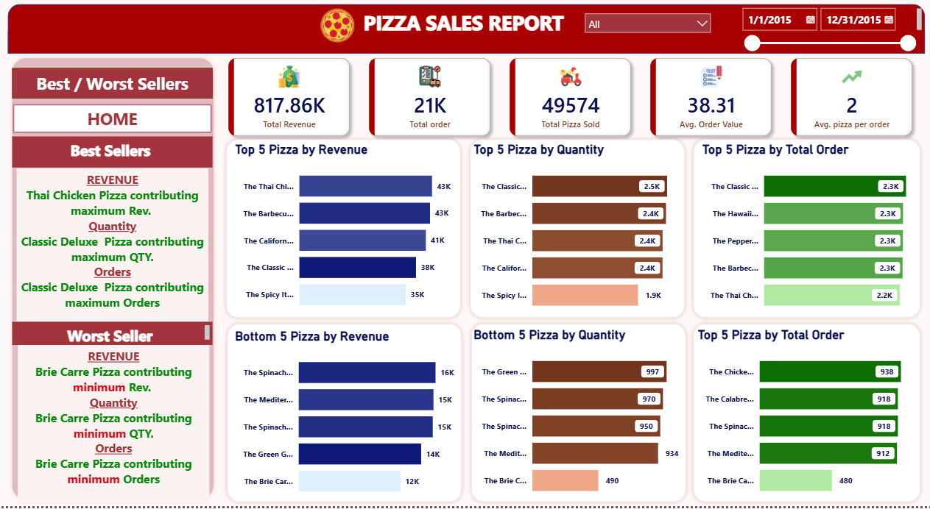BEST / WORST SELLERS